Kaleem OOAD Coursework

# Question 1: Use case realization

Whilst creating the sequence diagram, quite a few operations were found that I had to add to the analysis class diagram as shown below:

|  |  |
| --- | --- |
| **Class** | **Added Operations** |
| GUIGateway | ProcessShoppingListDelivery()  PromptUser(message:String) |
| Controller | connectToCloud()  findShoppingList(id:Integer) |
| CloudGateway | Connect()  submitQuery(itemLocation:Integer)  disconnect() |
| ShoppingList | editItemQuantity(quantity: Integer) |

Here is the updated analysis class diagram:

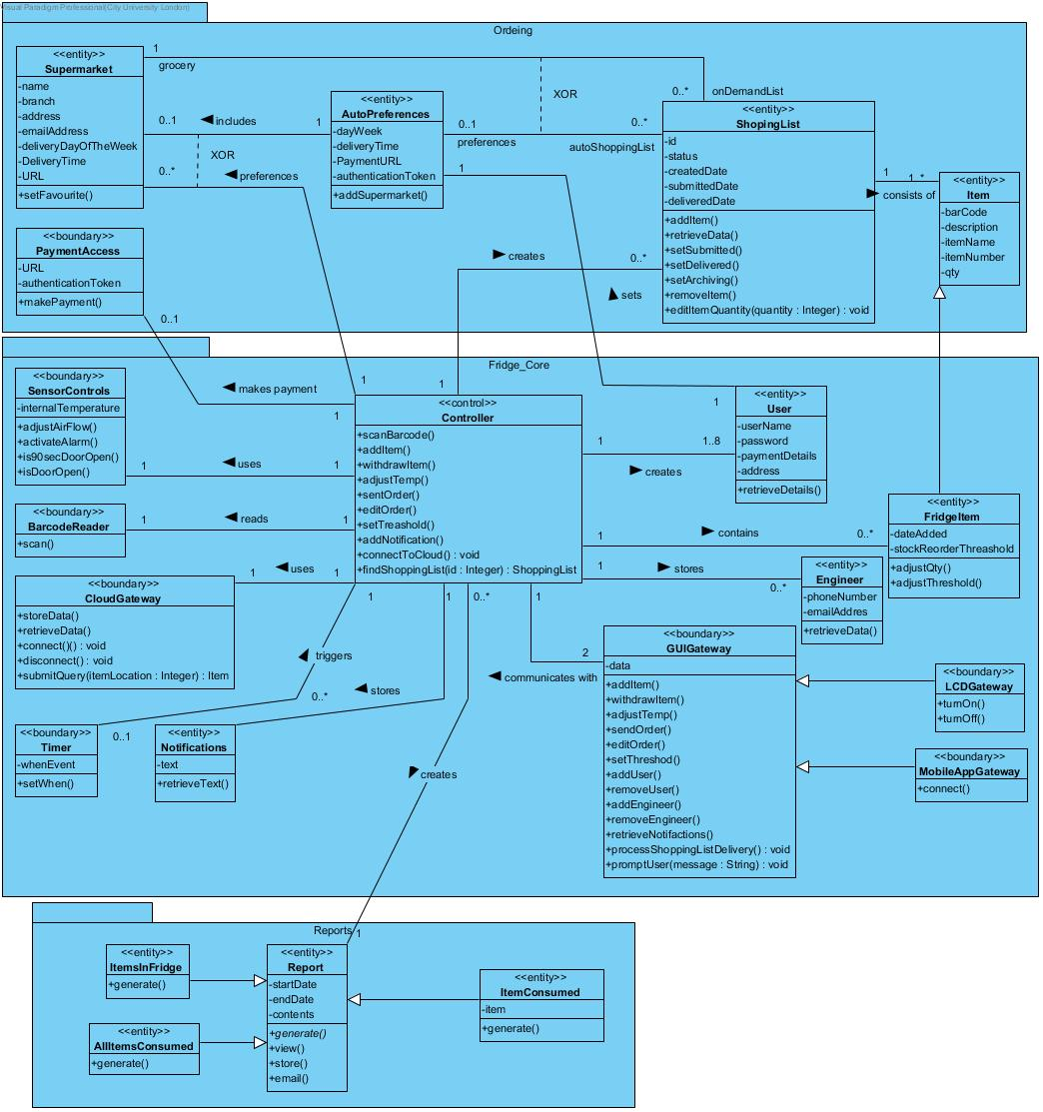

# Question 2: Design class diagram

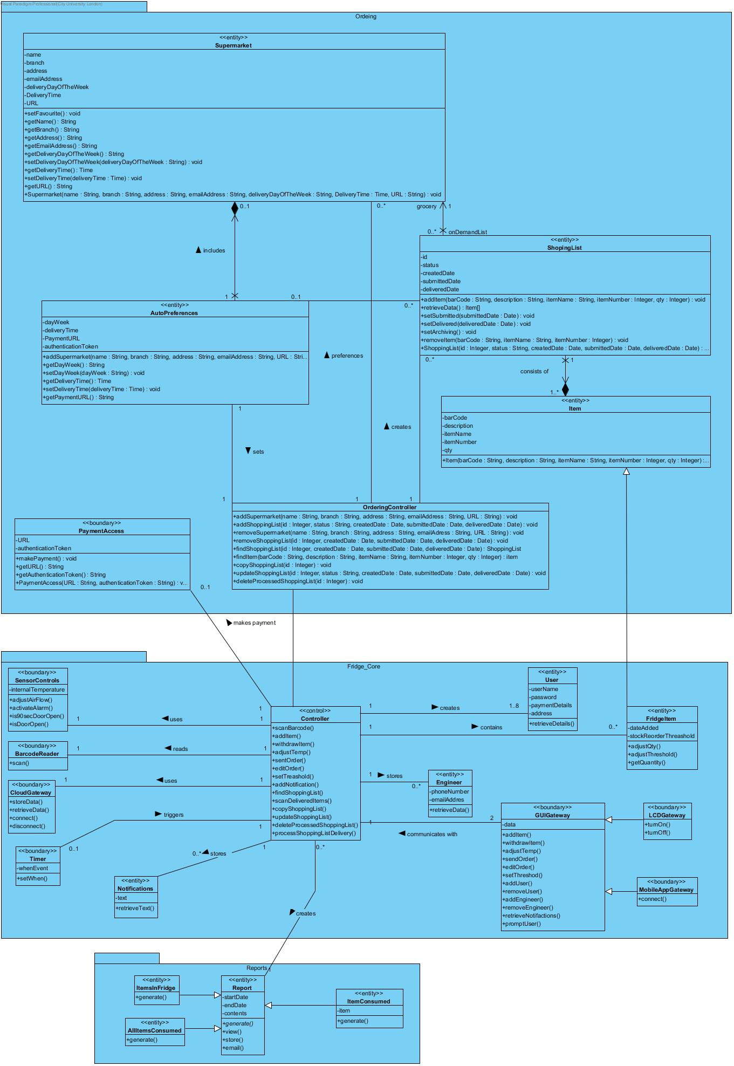

# Question 3: State machine

